|  |  |
| --- | --- |
| **Author** | Andrew Bartle |
| **Status** | Final |
| **Version** | 1.0 |

|  |  |  |
| --- | --- | --- |
| **Change Record** | | |
| **Date** | **Change** | **Document Version** |
| 11/26/2023 | Document Creation | 1.0 |

## System Components and Design

### Purpose

This project is for one of our clients, DriverPass. The purpose of this project is to build a system that provides better driving training than what is currently on the market.

### System Background

1. The client asked for a system that will provide better driving training to help people avoid failing DMV tests.
2. The system will provide better driving training by offering online classes and practice tests as well as on-the-road training.
3. The system will be online based and will allow users to easily pick from different packages that the company offers.

### Objectives and Goals

1. Online classes and practice tests
2. On-the-road training
3. Data access from any computer or mobile device
4. Restricted access per rights and roles
5. Customer needs to have the capability to make appointment, cancel, and modify appointments
6. User and employee appointment tracking
7. User shall have the option to select different packages
8. System shall be built flexible enough to disable packages

## Requirements

### Nonfunctional Requirements

1. There shall be 4 different roles: Admin, Employee, Management, and Customer
   1. Admin: Has access to modifying the system, including setting user access.
   2. Management: Has access to reports for tracking.
   3. Customer: Appointment scheduling, modification, cancelation, and all other customer facing features.
   4. Employee: has access to input driver notes and appointment scheduling.
2. Each driving lesson appointment shall be two hours long.
3. Business data shall be accessible online from any computer or mobile device.

#### Performance Requirements

1. The system shall be web-based so it can be accesses from online from computers and mobile devices.
2. The system shall be updated when there are new platform requirements.

#### Platform Constraints

1. The system will use MySQL a database hosted on Amazon’s AWS cloud services.
2. The system will web based. The suggested browser will be Google Chrome.

#### Accuracy and Precision

1. The system shall determine the user’s role based on their login credentials.
2. The system shall inform the admin if a location is offline.
3. The system shall inform the admin if any of the cloud services are down.

#### Adaptability

1. The structure of the system shall have the flexibility for changes to user accounts without code changes.
2. The IT admin must have full access to user accounts to reset passwords and block user accounts.
3. The IT admin must have full access to the system for maintaining and modifying the system.
4. The system shall be built with the latest SDKs to support the latest platform technology. Platform updates. Although the system will be built with the latest SDKs, the system shall be frequently tested with beta platform updates if available so issues can be identified and debugged before the platform updates are released to production.

#### Security

1. A username and password will be required to log into the system.
2. Passwords must be 15 characters long, include an alpha uppercase, alpha lowercase, number, and symbol.
3. Employees at the company shall have different rights and roles.
4. All connections between clients and servers shall be encrypted using a Secure Socket Layer (SSL) implementation.
5. An account shall be locked if a brute force attack is attempted is detected. The account will lock until the IT department can investigate the attach an ensure there are no vulnerabilities.

### Functional Requirements

1. The system shall provide a process for customers to create an account.
   1. When an account is created, the following information shall be captured: first name, last name, address, phone number, state.
   2. It shall be optional for the user to enter their payment details such as their credit card number, expiration date, and security code.
   3. It shall be optional for the customer to provide a photo.
2. The system shall validate user credentials while logging in.
3. If the user forgets their password, they should have the capability to automatically reset it by sending them a link to their email to reset it.
4. The system shall allow customers to schedule driving lesson reservations online. When scheduling reservation, they shall be able to select the day and time they wish to take the lesson if it is available.
5. The system shall give the customers the capability to make appointment, cancel, and modify appointments online.
   1. When a customer makes an appointment the pickup location and drop off location shall be collected.
   2. If the customer did not enter their credit card details during the creation of their account, their credit card number, expiration date, and security code must be collected for the appointment payment.
6. The system shall allow employees to make appointment, cancel, and modify appointments for customers.
   1. When an employee makes an appointment, the following information shall be collected from them: pickup location, drop off location, the customers first name, last name, address, phone number, state, credit card number, expiration date, and security code.
7. The custom shall be able to purchase one of three packages:
   1. Package One: Six hours in a car with a trainer.
   2. Package Two: Eight hours in a car with a trainer and an in-person lesson where DMV rules and policies are explained.
   3. Package Three: Twelve hours in a car with a trainer, an in-person lesson where the DMV rules and policies are explained, and access to an online class with all the content and material. The online class shall also include practice tests.
8. The system shall support the following features that are exclusive to management users:
   1. The ability to export in a xlsx file format that captures who made, canceled, and modified reservations. The report shall also include the driver, car, customer, and time of reservations.
   2. The ability to disable lesson packages.
   3. Notifications when the DMV has updates to rules, policies, or sample questions.
9. The system shall support online practice driving tests for customers.

### User Interface

1. Users will interact with the user interface on a web browser.
2. The home page shall show the online test progress, customer information, driver notes, a photo of the driver, a photo of the customer (if available), and special needs the customer may have. There shall be an edit button in the customer information section that shall open a form to edit customer information.

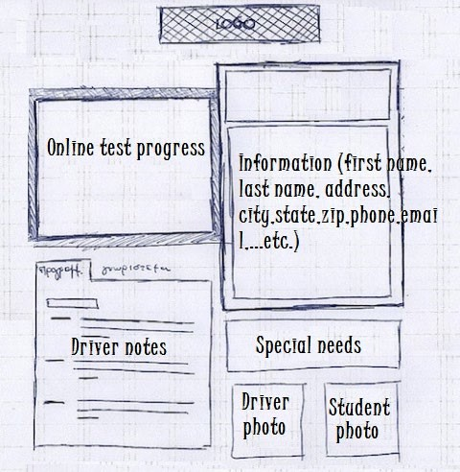

1. On the home page, the online test progress shall have a table that shows the tests the customer took. It should show what’s in progress and the ones that the customer completed. It shall show the test name, time taken, score, and status. The status could be not taken, in progress, failed, or passed.
2. On the home page, the driver notes shall be shown in a table format and populated with any comments the driver left as well as the times for the lessons.

**Example:**

|  |  |  |  |
| --- | --- | --- | --- |
| **Lesson Time** | **Start Hour** | **End Hour** | **Driver Comments** |
|  |  |  |  |

1. On the top of the home page, and every page throughout the website, there shall be a selection menu to open the following pages: Home, Online Practice Test, Appointments, Lesson Packages, and Admin (this option is dynamically displayed only when an Admin user in logged in).
2. The Online Practice Test page shall show the following:
   1. Different practice tests to select.
   2. When a practice test is selected the questions shall be displayed under the different test options and the test shall begin.
3. The Appointments page shall show the following:
   1. The appointment types.
   2. A calendar to select the day the customer wants to schedule an appointment.
   3. An option for the customer to select the time of the appointment.
4. The Lesson Package page shall show the following:
   1. The three lesson packages the DriverPass offers.
   2. The option for the customer to select and purchase any of the packages.
5. The Admin page shall show the following:
   1. Display of all user accounts.
   2. The option to reset passwords for user accounts.
   3. The option to set the role of each user account (by default all user accounts will be a customer account).

### Assumptions

1. The customers will have internet access on their mobile device or computer.

### Limitations

*Any system you build will naturally have limitations. What limitations do you see in your system design? What limitations do you have as far as resources, time, budget, or technology?*

1. The system is not accessible without internet.
2. Lesson packages cannot be added without help from a developer.

### Gantt Chart

*Please include a screenshot of the GANTT chart that you created with Lucidchart. Be sure to check that it meets the plan described by the characters in the interview.*

